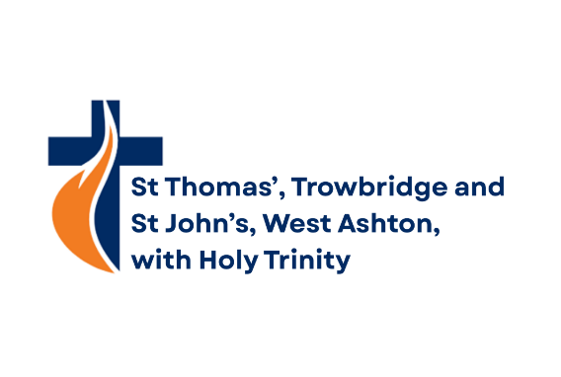

Monthly News October 2026
Monthly News October 2026

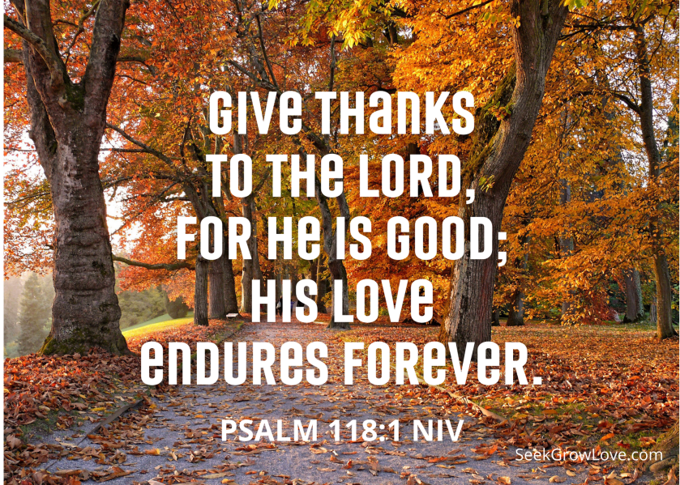

A Month of Steady Light
A Month of Steady Light

October has a particular mood to it. The mornings grow cooler, the evenings draw in, and the trees begin their slow, spectacular surrender to autumn. It’s a month that invites us to pay attention — not in a hurried way, but in a steady, thoughtful way.
There’s something deeply Christian about this season. Autumn reminds us that God is present not only in the bright, energetic months of growth, but also in the quieter, more reflective times. As the pace of life shifts, October gives us permission to breathe, to notice, and to remember that God’s faithfulness doesn’t dim with the daylight.
Prayer for October
God of light and steady grace,
walk with us through
this changing season.
Warm our hearts,
steady our steps,
and shine your quiet hope
into our days.
Amen.

In Scripture, God’s people often encounter Him most clearly in the in‑between moments — the wilderness, the waiting, the transitions. October is one of those “in‑between” months. Not quite the warmth of summer, not yet the celebrations of Advent. And yet God is here, working in the slow, unseen places of our lives.
“The Lord is my light and my salvation; whom shall I fear?”
Psalm 27:1

Psalm 27 is a psalm for people walking through changing seasons — David speaks of confidence not rooted in circumstances, but in God’s unwavering presence. As the days shorten and the world around us shifts, this verse reminds us that God’s light is not fragile or seasonal. It is steady, brave, and enough for whatever we face.

Perhaps this month finds you carrying something heavy. Perhaps you’re stepping into something new. Perhaps you’re simply trying to keep going. Wherever you are, hear this truth: God’s light is not seasonal. It doesn’t flicker with the weather or fade with the leaves. Jesus calls Himself the Light of the World — not just in spring’s optimism or summer’s brightness, but in every season we walk through.

As a church family, we see that light in so many ways:
- in the kindness shared over coffee
- in the courage of those trying something new
- in the faithfulness of volunteers who quietly keep things going
- in the welcome extended to newcomers and long‑timers alike

These small lights matter. They remind us that God is at work among us, weaving hope into ordinary days.
So, this October, let’s choose to carry the light we’ve been given. Let’s be people who notice God’s presence, who encourage one another, and who bring warmth into the cooling days. And as the leaves fall, may we remember that God is still growing something good — sometimes beneath the surface, sometimes in ways we don’t yet see.
Reflection
Where in my life might God shine His warming, freeing light — and where might I reflect God’s light to give others hope?
May you know God’s steady light, God’s peace, and God’s gentle leading throughout this month.
Every blessing,
Simon

St John’s Update
St John’s Update
Here we are in October, changes are afoot - shorter days; the weather; the colour around us; clocks falling back an hour and the start of Christmas shopping hysteria!
The time of glowing red of the autumn fires, the smell of the burning leaves. Glittering stars in the frosty skies, the wind sighing round the eaves. Autumns here - winter is nigh; but Spring will come round by and by!
St John’s has been busy cleaning out the belfry of bird nesting debris; safety white lines repainted on steps; churchyard made tidy (it has actually returned to green after the parched summer); a PCC Meeting took place. Two services were held during the month but on 12th September, there was much excitement as Olivia C and Niall B were married - a very special and happy day for all concerned. (Please see separate photographs).
The next St John’s Services will be :
Sunday, 4 October - Harvest Festival (all items donated will be given to Trowbridge Foodbank).
Sunday, 18 October - Holy Communion
It would be great to welcome you.
“He makes grass grow for the cattle and plants for people to cultivate - Bringing forth food from the earth; wine that gladdens human hearts; oil to make their faces shine and bread that sustains their hearts “ Psalm 104: 14-15
Amen.
Enjoy the colour and fragrances of Autumn. Stay Safe.
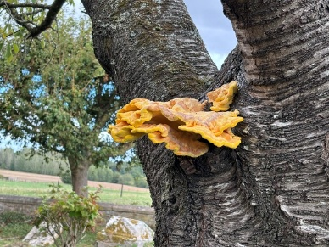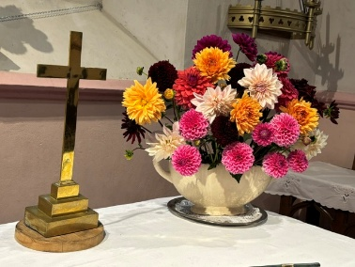

The wedding of Olivia Collyer and Niall B took place at St John’s Church on Saturday, 12 September.
We wish the happy couple every blessing for their future life together.
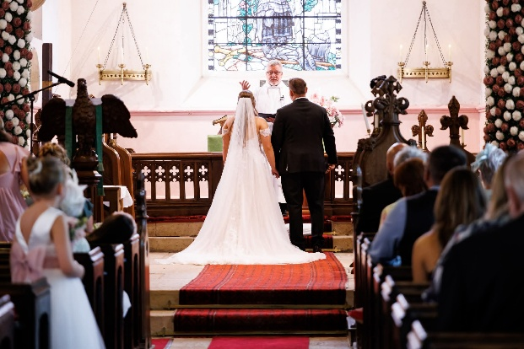
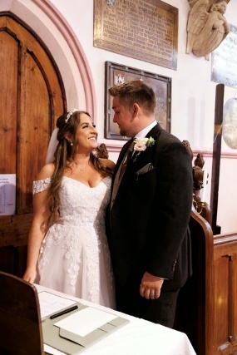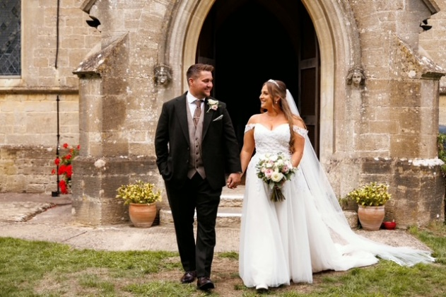



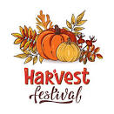

St John’s Church, West Ashton
Warmly Invites You To Their
HARVEST FESTIVAL SERVICE
On Sunday, 4 October - 10.30am
“Thank the Lord for Harvest -
He provides you with plenty of food
And fills your heart with joy”
Acts: 14-17b
(If you would like to donate any tinned, packet food or toiletries, this will be given to
Trowbridge Foodbank for distribution to the needy).
Thank You.





An Evening Of Festive Song”
By The



At St John’s Church - West Ashton

Friday, 4th December, 2026 - 7.30pm

Come & Celebrate The
Commencement Of The Festive Season
& St John’s Church 180th Birthday

Tickets £8 (Under 12s Free)
Includes Mulled Wine & Mince Pie
Tickets From :
Jo Watkins 01225 753196 / Jean Robertson 01225 760368

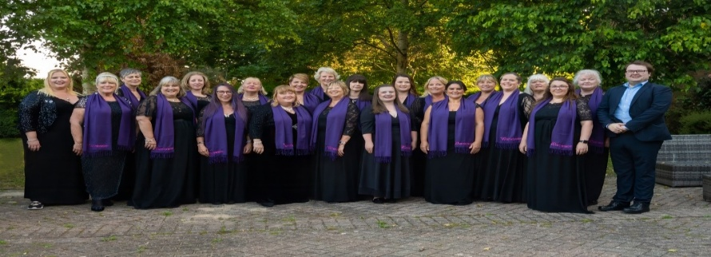

Small Groups
Have you ever wondered what leading a Small Group entails?
Might you be able to serve our church in this way? Come and find out! Sunday 18th October.
As a growing church, we need to establish new Small Groups. We also need to have potential leaders ‘in waiting’ who are ready to help establish a new group when its needed. At the moment, we have a number of people who would like to join a suitable Small Group.
Is God nudging you to offer your gifts to lead a Small Group? This is your opportunity to find out more!
WHEN? Sunday 18th October, after the morning service at St Thomas’s (12.30 or thereabouts for 30 minutes max.)
WHERE? Audrey Prentice Room.
WHO’S THIS FOR? Anyone who wants to know more about what it means to lead a Small Group.
WHAT’S PLANNED? Andy Bennett, a relatively new Small Group leader at St Thomas’s, will share his experience of leading a Small Group, (what they are for, why he thinks they are important, what happens in a Small Group and what is needed in a Small Group leader.) Simon Pope will be alongside to help answer any other questions you might have.
If you think you have gifts that could be used to serve in this way, and that God might be encouraging you to take this on, get your coffee straight after the service on 18th October and join the session.

Training sessions for all new and existing Small Group leaders are planned for later in the autumn. Come along on 18th October and get a taste for what is involved.
Training Dates for potential and existing Small Group Leaders
The same training is being offered at three different times to enable everyone to be able to attend. Choose from one of the following three options:
Monday 2 November and Monday 9th November, 7.30-9.00pm
OR
Sunday 8th November, 2-5.30pm
OR
Saturday 21 November, 2-5.30pm
Sign up details will be available nearer the time.
A, Small Group Coordinator.
Messy Church

Messy Church sessions are aimed at families with children between the ages of 4 and 11 but younger children and older children and young people are more than welcome. The idea is to provide a relaxed environment where all ages can learn more about Christian faith, worship the Lord together and have fun. If you know families with children who may like to come along please contact the Church office to find out more. Our next session is on October 10th at St Thomas' from 10.45 until 1pm, we'll have crafts and activities in the Church hall, followed by a bible story, songs, prayers and an adult discussion time in Church finishing with a lunch together in the hall.

Mercy Ships
St Thomas’ Church mission focus for October and part of November is Mercy Ships.

Mercy Ships is a global Christian Charity following Jesus’s example of bringing hope and healing to those suffering from disability, disfigurement and disease.

This is achieved through the provision of hospital ships and partnering with African nations to help improve their healthcare and provide free surgery to those most in need.

There are two hospital ships, the Africa Mercy and Global Mercy. The Mercy Ships crew of the Africa Mercy is led by a team of volunteers from up to 40 nations, all of whom give their time and expertise for free.

The Global Mercy was undergoing maintenance in July and is now in Ghana until the end of the year, having previously been in Sierra Leone. The Africa Mercy has been in Madagascar.

Among the countries Mercy Ships serves, which lie on the lower third of the World Health Organisation’s Human Development Index, access to safe, affordable and timely surgery is extremely limited. As a result, countless people suffer and die from “diseases of poverty” that can easily be cured.

A story about 2 year old Armella.

Armella was born with a large lump behind her ear. Every day, her tumour grew more and more. Instead of wanting to play, other children just stared at her.
Two years later, the growth was too heavy for little Armella to bear.

Armella’s mum, prayed that one day Armella could get surgery.
Her prayers were answered when the Africa Mercy sailed to Madagascar. This floating hospital brought state-of-the-art surgical theatres, medical experts, and compassionate care to the hardest-to-reach communities. To her mum’s overwhelming gratitude, Armella was booked in for free surgery.

A Mercy Ships vehicle collected her and her mum from home and took them all the way to the hospital ship. Armella slept in her mum’s arms as Mercy Ships volunteer nurses examined her before surgery.
Dr Manjit Dhillon, Mercy Ships volunteer surgeon said, “Her tumour was 280g, about the weight of a large grapefruit. For a two-year-old, that’s a lot of weight to carry.”

At the end of surgery, nurses lifted Armella into her mum’s arms. A hospital trolley was pushed to carry them both. As Armella opened her eyes, a bandage gently wrapped around her wound, her mum smiled with relief.

Free from the burden of her tumour, Armella’s life has changed for good. Her mum says, “Mercy Ships is a blessing, a light and a rescue for me and Armella. When she had that condition, I suffered with her. When she recovered, I recovered too.”

As well as completing thousands of urgent operations in every country visited by Mercy Ships, the organisation also works closely with host nations to improve the way healthcare is delivered across the country, by training and mentoring local medical staff, and renovating hospitals and clinics.

More information on the above can be found on the Mercy Ships website mercyships.org.uk and there will be a talk given by Stephanie Elcock, a visiting speaker on 15th November during the morning service. Your support is appreciated to this life changing cause and we hope you can join us for this service.
Many thanks Caroline F

Mission Organisations and Partners

St Thomas' has a long history of supporting the work of Tearfund and of supporting the Deanery Link with Kadugli Diocese in Sudan. However we currently do not have representatives for either of these two important ministries.
If you would be interested in either of these opportunities or would like to find out what would be involved please speak to Andrew S or one of the other Mission Organisations and Partners Representatives. These are both positions that could be shared between two people. It is a valuable way to support mission and to help church members to be kept informed.

Please can you send your articles for the Monthly News as
soon as possible.
Deadline for November Monthly News is 22nd October

Decorating the Church Hall

It’s twenty years or so since the Church Hall was last decorated and it’s looking a bit tired. The PCC have decided to have a new floor laid in the Hall, so before that happens, it seems the right time to spruce up the interior with a coat of paint.

It would be great to have a working party to do this, although we’d need to use the half term holiday when the Hall isn’t heavily used. So, I’m proposing the work to be done on Thursday 22nd, Friday 23rd, Saturday 24th October. We may need to use the Monday 26th October depending how much is accomplished by then.

If you feel you can spare a couple of hours on any of those days, please sign the sheet at the Information Point or let John C know. The more people, the easier and quicker it can be. It’s a great opportunity for fun and fellowship while at the same time making our rooms look more inviting.
More details in a few weeks.



Viney Hill
Back in 1992 a group at St Thomas’ wanted somewhere to go for a weekend together. Val and I started a search. Through a CCI booklet we found a place in the Forest of Dean. We went there to see what it was like. Steve Hunt, the Warden showed us round a field, a climbing frame and some green scout tents. Inside there was a small kitchen, a small eating area with tables and chairs and a somewhat larger room with a pot belly stove and lots of cobweb. They offered about three activities, canoeing, archery and some climbing. We went there first in 1993 and had great time. Especially around the camp fire in the evenings. At first we went there every year but under Allan it eventually became alternate years.
Over the years many improvements were made including enlarging the kitchen and dining room, turning the meeting room into an games/meeting room, replacing the old wooden climbing frame with a state of the art multipurpose climbing wall, turning the vicarage into dormitory accommodation and then very recently heated sleeping pods replacing the tents. Of course there came a time when Val and I felt it was time to cease leading the weekend which was when Harriet and Geoff rose to the challenge in 2009. The two of them, (aided by those that attend), make a great job of it, thank you both.
We now visit on the Saturday and have a great time, laughing, eating and chatting. We thoroughly recommend it, please join us next time and of course there’s always the vicarage we could use.
Some comments from those who attended this year:
"Fantastic" "Great family atmosphere; everyone helping each other; looking out for each other; Great big family; everyone getting stuck in".
Messy church dad ' I've never laughed so much, my face hurt!'
Messy church child ' I don't want to go home. Can I come back next year?'
Stephen led a lovely service on Sunday morning and had everyone working together to plait wool demonstrating it is easier when we help each other.
My favourite part was watching Louie going everywhere hand in hand with little Andrew.
Can you recognise yourself or your children in any of these old photos from 2003 and 2014?
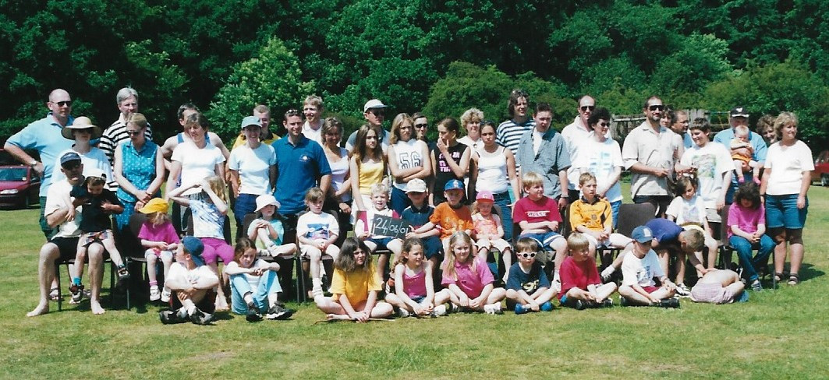
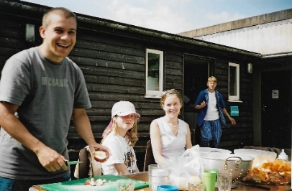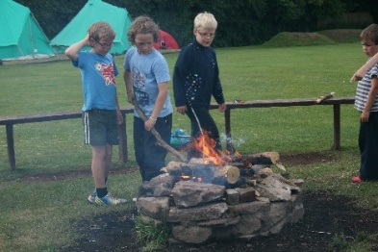

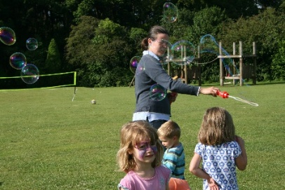

Toddler Group

The Toddler Group runs on Monday mornings during school terms from 10.00am until 11.45am at Holy Trinity. Our aim is to provide local families with children up to school age with a safe and happy place for children to play, learn and interact. We also offer a welcoming and safe place for parents and carers to meet, make friends and feel supported. We always pray before each session that we can reach out to these families with the love of Jesus. We would love to invite anyone to come and visit us to see what goes on, it's great fun and our families are lovely. Also if you know any families with young children please feel free to bring them along or invite them: please ask for a flier to give them.
Thank you so much to our Church family for all your support.
The Toddler Team (Jane B, Jo D, Lauren M, Ivor S, Claire S and Stephen B)

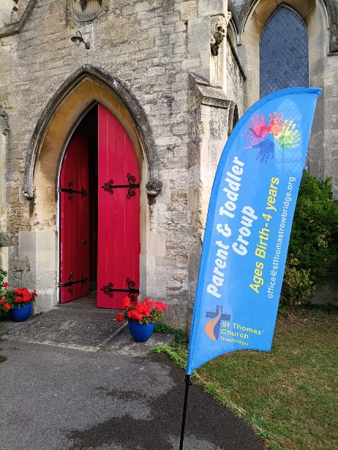
The Island

The Island Afterschool club continues to flourish.

It runs from 3.00-4.45pm every Tuesday in term time at Holy Trinity (the church on the roundabout) with snooker, table tennis, badminton, football and a cupboard full of board games all of which the helpers really enjoy playing with the young people.

Currently we have Mandi, Elle, Geoff and Harriet every week with Paul and John alternating weeks and Martyn and Ivor helping once a month. If anyone would be prepared to help serve the free hot chocolates and donuts from 3.30pm and wash up afterwards you would be very welcome to join us and it would mean Mandi doesn't have to tear herself away from playing games as she gets quite involved in them!

Also if you have children or grandchildren or know youngsters in years 7-11 then tell them about it and they can scan the barcode below to register.

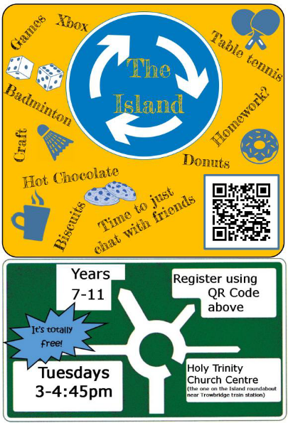

Impax
For nearly 30 years a team from St Thomas Church Trowbridge
(and previously other local churches) have run a youth group on the Paxcroft mead estate.

It is for ages 10-15 years with an intention to give young people a safe place to hang out, have fun and hear about Jesus . We currently have a strong core of just under 20 young people attending on Wednesday evenings.

We do night walks , sleepovers , safari suppers, have visiting speakers and lots of fun. We are open to all young people attending and welcome anyone who wants to give us a try. We serve tuck , play games and have a little talk every week. Signing up is easy, at impax@stthomastrowbridge.org it only costs £1.50 per week.

If you know of any young person who might fancy trying us out let myself or any of the Impax team know and your first week is free.

Please pray for Hannah Lake, Youth Worker, as she gets to know the young people and for more young people to join.

Thank you, Laura Y

Kadugli Newletter
and Prayer Diary
“Please do not grow tired of praying for Sudan”
(Archbishop Ezekiel)
Various political moves are being made, both in Sudan and elsewhere, the bring a lasting peace to the nation. So far we are waiting for substantial progress, but we are asked to pray.

We have reported before on the drastic shortages of food, caused in part by the breakdown of the irrigation subsystem, in part also by farm workers being driven from the land, and in part by direct violent action. In the past month it has been reported that, in defiance of international law, a drone has been used to attack a food convoy. Which side fired the drone isn’t stated. Separately, an organisation named Justice Africa Sudan accuses both sides of deliberately using starvation as a method of warfare. It points to sieges, road blockades, the obstruction of food supplies to areas controlled by opponents, and the destruction of warehouses, water sources and farms. It also accuses the belligerents of restricting humanitarian access. Such tactics, the organisation argues, amount to war crimes and have aggravated an economic crisis in which food and essential commodity prices have more than doubled in a month.

Kadugli.
To make matters worse, the crisis is being compounded by poor rainfall in rain-reliant farming areas, including South Kordofan, which contains Kadugli Diocese, and threatens harvests just as access to food and other essentials is deteriorating.

Elsewhere in Sudan, the Sudanese Doctors’ Syndicate has warned of a seriously deteriorating health situation, particularly in Khartoum, Omdurman, and Gezira state due to such factors as poor sanitation, overcrowding and the destruction of medical infrastructure.
How long before this hits Kadugli, where the health system is already in a very poor state?

Last month we reported that the church in Kadugli was preparing to reach out to the largely Moslem influx of refugees in Nuba Mountains. We regularly send money to Bishop Hassan towards humanitarian needs, but this month we have sent an additional £300 to support this planned outreach project. This is a one-off contribution, but we should like to be able to send more on a regular basis.

Across Bradford Deanery there has been a continuous warm and generous response to this need; thank you all. We are making a special donation to support evangelism, but we should like to make this a regular donation. The church in Kadugli is intensely grateful for our support, both financial and in prayer. Please continue to give via your church if you can, or directly. The account details are:

Bank: Lloyds Bank Trowbridge
Name of Account: Bradford Deanery
Sort Code: 30-98-75
Account No. 00710285
Reference Kadugli. (N.B. This is important)

Now we in Bradford Deanery would like to support our brothers and sisters in Christ, both those who are actively evangelising, and those who are not. They need our prayers, but also we should like to be able to give more for material support, especially this Christmastide.
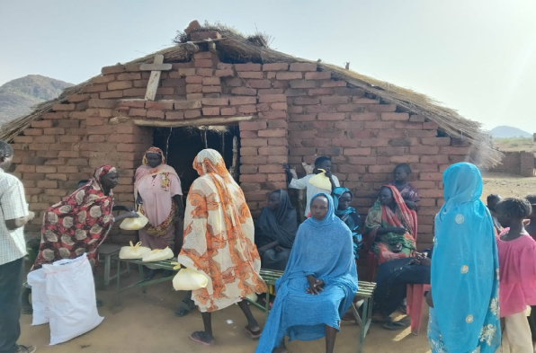

Many churches will already have planned their services and other events for the Advent and Christmas seasons. If you haven’t, perhaps you will soon be doing so. Could we suggest you take part in our Bradford Deanery Kadugli Christmas Appeal by raising some money by whatever means seems best to you. For example, you may wish to make a special collection, or use the proceeds of a carol service, or profits from a sale, or any other means you like. And could you please send any money raised to the Bradford Deanery account mentioned above, but making the reference “Kadugli Appeal” instead of just “Kadugli”. Many thanks.

Other Kadugli News. We also note that despite the severe hardship caused by war, famine and disease, the church leadership in Kadugli continues to shepherd their flock. Bishop Hassan speaks of a week-long course held annually to study the Bible or more meaningfully “The Word of God”. On a personal level, Bishop Hassan writes “My daughter Yasmine’s success in the Sudanese certificate qualifies her for university. Our hearts were happy with this success. Thank you to everyone who was praying for the family”. He asks also that we pray for a trip to Juba to renew the passport.

Let us join with our brothers and sisters in Kadugli in prayer.
Prayer Diary
“Please do not grow tired of praying for Sudan”
(Archbishop Ezekiel)
Bishop Hassan writes:
We give thanks for His grace. The Gospel course has begun in every parish church to study the Word of God for a full week, This programme is annual. We pray for stability and peace in Sudan, especially with the political moves taking place. Pray for an end to the war, the fighting, and the shedding of blood on the ground. Pray for the situation in Sudan, the drought, the lack of rain, the lack of agricultural success, the conditions are not good, the increase in displacement, and the harsh humanitarian situation. Pray for the ministers during this week in the Gospel course programme, that the Lord will give them the word to save souls and extend the Kingdom of God on earth.

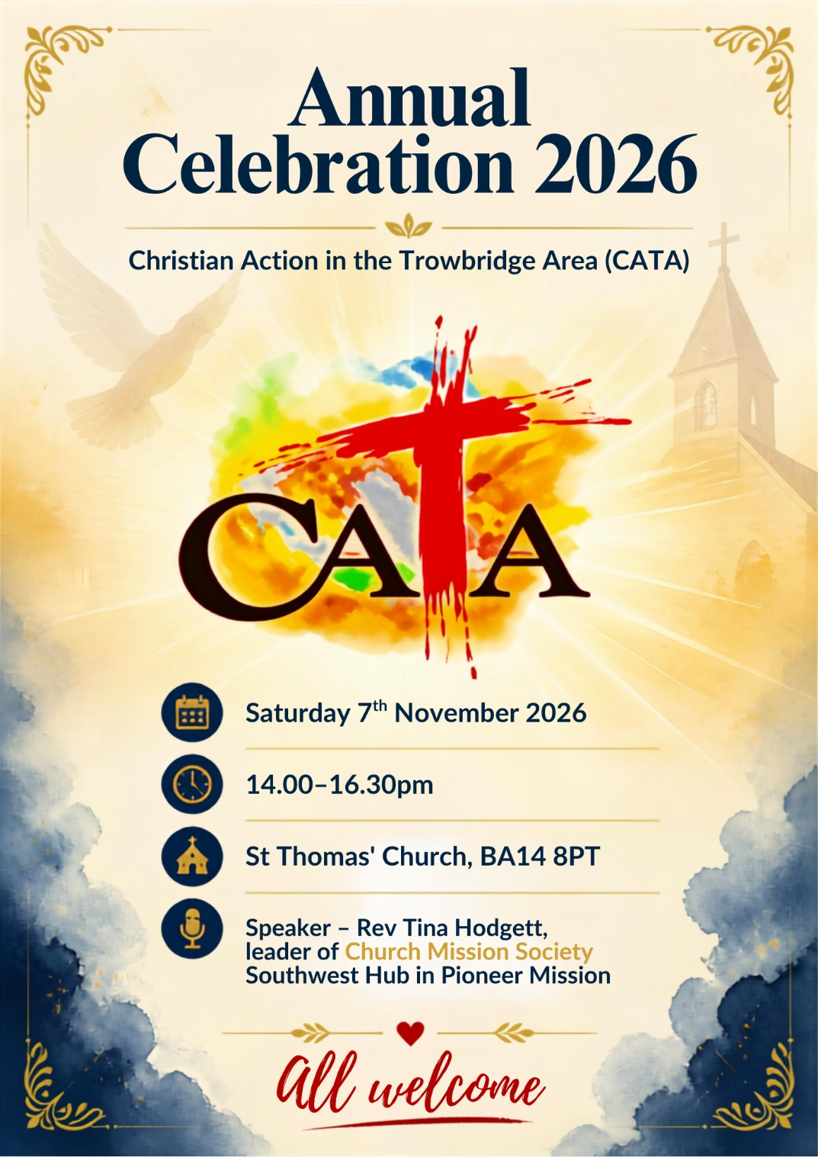

Living Nativity in Schools
Volunteer Opportunity


Are you free in December?

We have been invited by The Mead and Castle Mead Schools to present the Living Nativity to them again this year. This is an interactive telling of the Christmas story and is a great outreach opportunity. We have presented it to hundreds of children over the years and it is always very well received.

We have a confirmed date of Thursday 17th December at The Mead and EITHER Tuesday 15th OR Wednesday 16th at Castle Mead. For both presentations we need people from 8.30 - 11.30 am. We already have some volunteers, but we need a few more. Volunteers dress up as one of the characters from the story, and most speak a few lines. If you are interested please chat or email Alice or Stephen B.

Volunteer Opportunity

Flower arranging:


Have you thought about displaying flowers in Church to celebrate an event – an anniversary or in memory of someone? If so join our team will give you support. If you are interested, please contact the Church Office.
office@stthomastrowbridge.org

Serving coffee:

Do you want to get to know people in the Church, putting names to faces or faces to names, then why not be a server at coffee & chat after the services, it won’t be every month, come and be a part of a team, who will help you learn the ropes. If you would like more details, do have a chat with John C

There are many other volunteer opportunities, if you would like to know more the leaders would love to have a chat with you, or the Information Point will give you more details.

